01_Build a User and Order Management System
order-service
OrderController.java
package com.example.orderservice.controller;

import com.example.orderservice.dto.UserDTO;
import com.example.orderservice.feign.UserClient;
import com.example.orderservice.model.Order;
import com.example.orderservice.service.OrderService;
import org.springframework.web.bind.annotation.*;

import java.util.List;

@RestController
@RequestMapping("/orders")
public class OrderController {
private final OrderService service;
private final UserClient userClient;

public OrderController(OrderService service, UserClient userClient) {
this.service = service;
this.userClient = userClient;
}

@GetMapping
public List<Order> getAllOrders() {
return service.getAllOrders();
}

@PostMapping
public Order createOrder(@RequestBody Order order) {
return service.createOrder(order);
}

@GetMapping("/users")
public List<UserDTO> getAllUsers() {
return userClient.getAllUsers();
}

@GetMapping("/users/{id}")
public UserDTO getUserById(@PathVariable Long id) {
return userClient.getUserById(id);
}
}
UserDTO.java
package com.example.orderservice.dto;

public class UserDTO {
private Long id;
private String name;
private String email;

public UserDTO() {}

public UserDTO(Long id, String name, String email) {
this.id = id;
this.name = name;
this.email = email;
}

public Long getId() { return id; }
public void setId(Long id) { this.id = id; }

public String getName() { return name; }
public void setName(String name) { this.name = name; }

public String getEmail() { return email; }
public void setEmail(String email) { this.email = email; }
}
UserClient.java
package com.example.orderservice.feign;

import com.example.orderservice.dto.UserDTO;
import org.springframework.cloud.openfeign.FeignClient;
import org.springframework.web.bind.annotation.*;

import java.util.List;

@FeignClient(name = "user-service", url = "http://localhost:8081")
public interface UserClient {

@GetMapping("/users")
List<UserDTO> getAllUsers();

@GetMapping("/users/{id}")
UserDTO getUserById(@PathVariable("id") Long id);
}
Order.java
package com.example.orderservice.model;

import jakarta.persistence.*;

@Entity
@Table(name = "`order`") // Escaping "order" (SQL reserved keyword)
public class Order {

@Id
@GeneratedValue(strategy = GenerationType.IDENTITY)
private Long id;

private String product;

@Column(name = "user_id")
private Long userId;

// Getters & Setters
public Long getId() { return id; }
public void setId(Long id) { this.id = id; }

public Long getUserId() { return userId; }
public void setUserId(Long userId) { this.userId = userId; }

public String getProduct() { return product; }
public void setProduct(String product) { this.product = product; }
}

OrderRepository.java
package com.example.orderservice.repository;

import com.example.orderservice.model.Order;
import org.springframework.data.jpa.repository.JpaRepository;

public interface OrderRepository extends JpaRepository<Order, Long> {
}
OrderService.java
package com.example.orderservice.service;

import com.example.orderservice.model.Order;
import com.example.orderservice.repository.OrderRepository;
import org.springframework.stereotype.Service;

import java.util.List;

@Service
public class OrderService {
private final OrderRepository repo;

public OrderService(OrderRepository repo) {
this.repo = repo;
}

public List<Order> getAllOrders() {
return repo.findAll();
}

public Order createOrder(Order order) {
return repo.save(order);
}
}
OrderServiceApplication.java
package com.example.orderservice;

import org.springframework.boot.SpringApplication;
import org.springframework.boot.autoconfigure.SpringBootApplication;
import org.springframework.cloud.openfeign.EnableFeignClients;

@SpringBootApplication
@EnableFeignClients(basePackages = "com.example.orderservice.feign")
public class OrderServiceApplication {
public static void main(String[] args) {
SpringApplication.run(OrderServiceApplication.class, args);
}
}
application.yml
server:
port: 8082

spring:
datasource:
url: jdbc:mysql://localhost:3306/orderdb
username: root
password: root
jpa:
hibernate:
ddl-auto: update
show-sql: true
database-platform: org.hibernate.dialect.MySQLDialect

logging:
level:
org.hibernate.SQL: debug
org.hibernate.type.descriptor.sql.BasicBinder: trace

user-service
UserController.java
package com.example.userservice.controller;

import com.example.userservice.dto.UserDTO;
import com.example.userservice.model.User;
import com.example.userservice.service.UserService;
import org.springframework.web.bind.annotation.*;

import java.util.List;

@RestController
@RequestMapping("/users")
public class UserController {

private final UserService service;

public UserController(UserService service) {
this.service = service;
}

@GetMapping
public List<UserDTO> getAllUsers() {
return service.getAllUsers();
}

@GetMapping("/{id}")
public UserDTO getUserById(@PathVariable Long id) {
return service.getUserById(id);
}

@PostMapping
public UserDTO createUser(@RequestBody User user) {
return service.saveUser(user);
}
}
UserDTO.java
package com.example.userservice.dto;

public class UserDTO {
private Long id;
private String name;
private String email;

public UserDTO() {}

public UserDTO(Long id, String name, String email) {
this.id = id;
this.name = name;
this.email = email;
}

// Getters & Setters
public Long getId() { return id; }
public void setId(Long id) { this.id = id; }

public String getName() { return name; }
public void setName(String name) { this.name = name; }

public String getEmail() { return email; }
public void setEmail(String email) { this.email = email; }
}
User.java
package com.example.userservice.model;

import jakarta.persistence.*;

@Entity
public class User {
@Id
@GeneratedValue(strategy = GenerationType.IDENTITY)
private Long id;

private String name;

private String email;

// Getters & Setters
public Long getId() { return id; }
public void setId(Long id) { this.id = id; }

public String getName() { return name; }
public void setName(String name) { this.name = name; }

public String getEmail() { return email; }
public void setEmail(String email) { this.email = email; }
}
UserRepository.java
package com.example.userservice.repository;

import com.example.userservice.model.User;
import org.springframework.data.jpa.repository.JpaRepository;

public interface UserRepository extends JpaRepository<User, Long> {
}
UserService.java
package com.example.userservice.service;

import com.example.userservice.dto.UserDTO;
import com.example.userservice.model.User;
import com.example.userservice.repository.UserRepository;
import org.springframework.stereotype.Service;

import java.util.List;
import java.util.stream.Collectors;

@Service
public class UserService {

private final UserRepository repository;

public UserService(UserRepository repository) {
this.repository = repository;
}

public List<UserDTO> getAllUsers() {
return repository.findAll().stream()
.map(user -> new UserDTO(user.getId(), user.getName(), user.getEmail()))
.collect(Collectors.toList());
}

public UserDTO getUserById(Long id) {
User user = repository.findById(id).orElseThrow();
return new UserDTO(user.getId(), user.getName(), user.getEmail());
}

public UserDTO saveUser(User user) {
User saved = repository.save(user);
return new UserDTO(saved.getId(), saved.getName(), saved.getEmail());
}
}
UserServiceApplication.java
package com.example.userservice;

import org.springframework.boot.SpringApplication;
import org.springframework.boot.autoconfigure.SpringBootApplication;

@SpringBootApplication
public class UserServiceApplication {
public static void main(String[] args) {
SpringApplication.run(UserServiceApplication.class, args);
}
}
application.yml
server:
port: 8081

spring:
datasource:
url: jdbc:mysql://localhost:3306/userdb
username: root
password: root
jpa:
hibernate:
ddl-auto: update
show-sql: true
database-platform: org.hibernate.dialect.MySQLDialect

logging:
level:
org.hibernate.SQL: debug
org.hibernate.type.descriptor.sql.BasicBinder: trace

OUTPUT
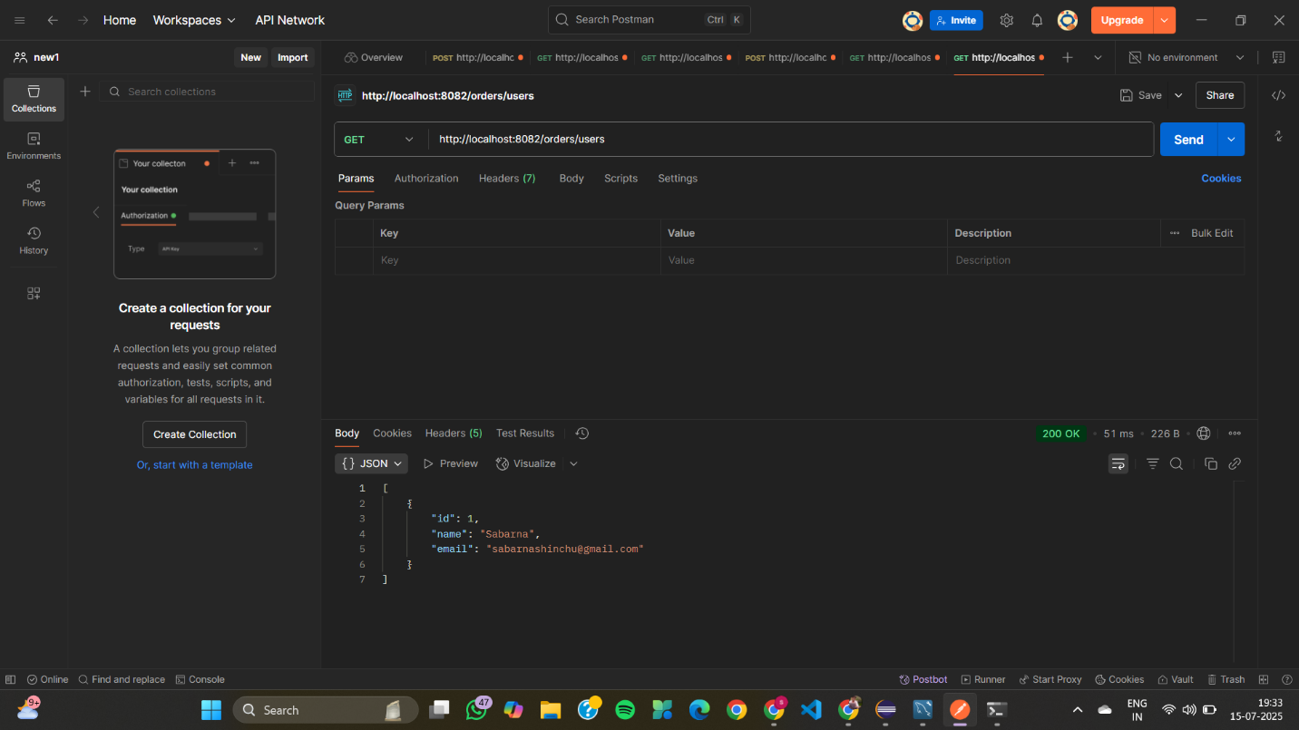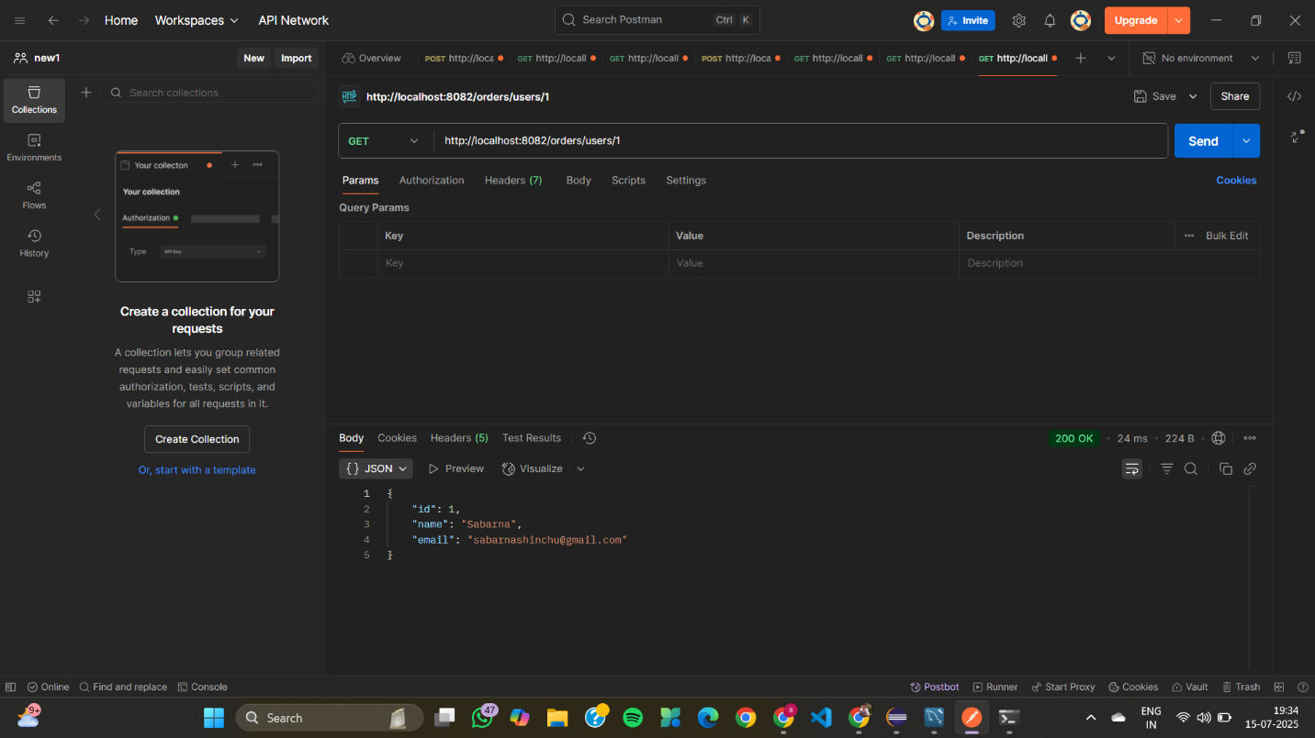
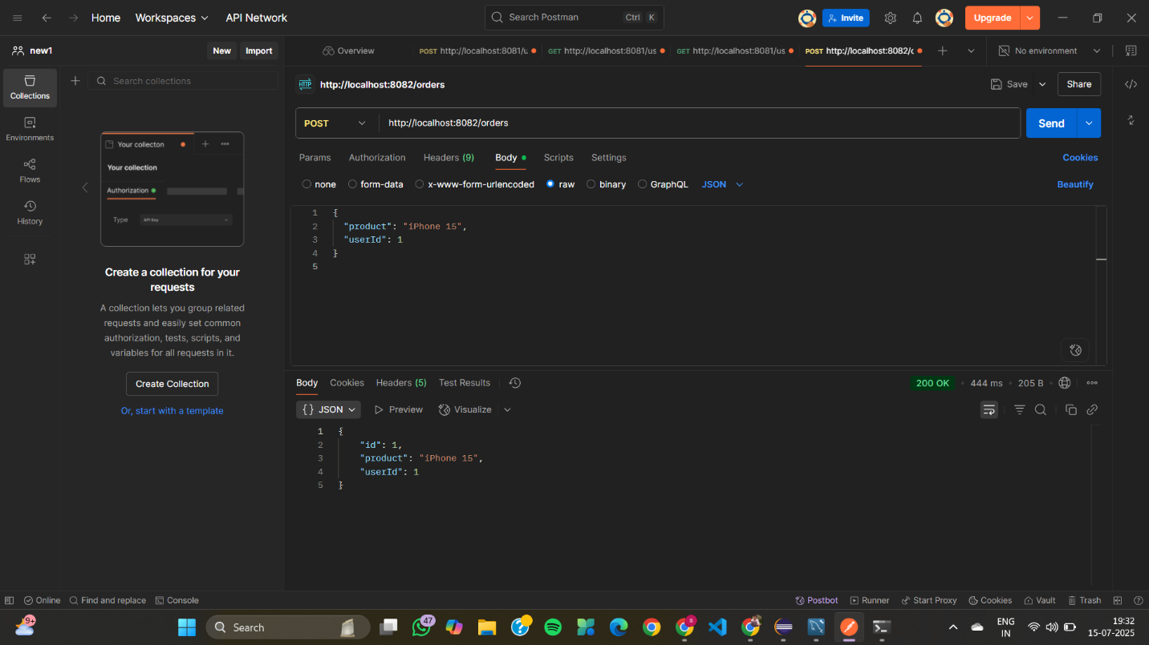


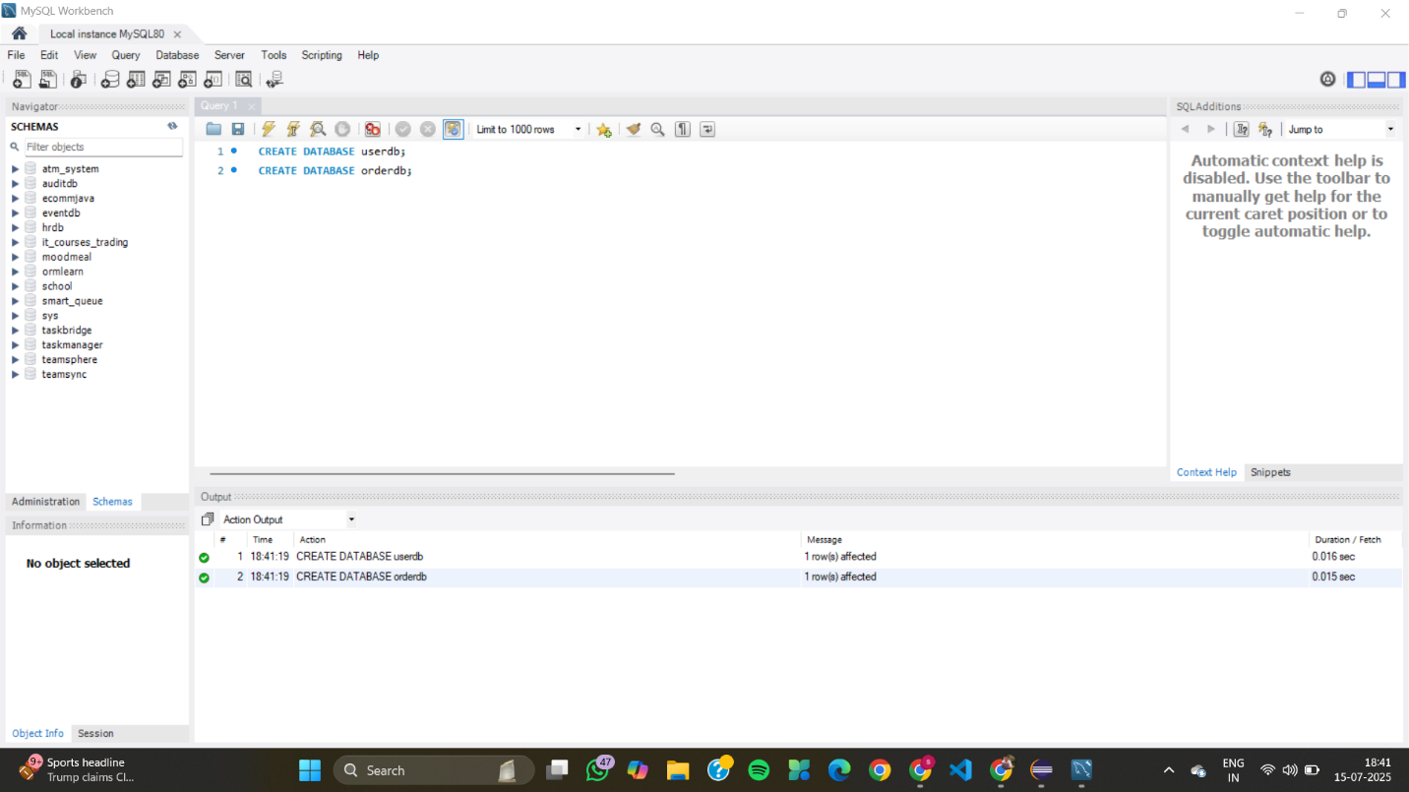
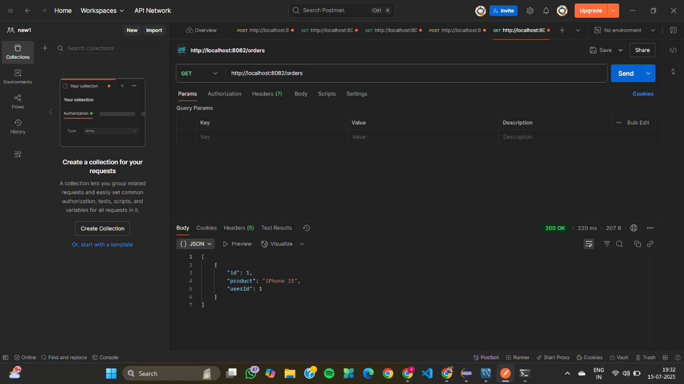
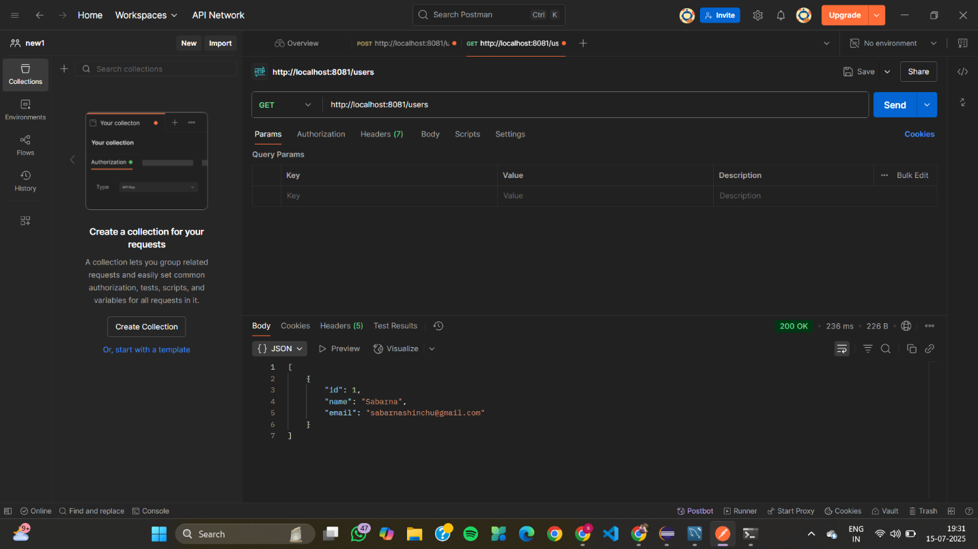
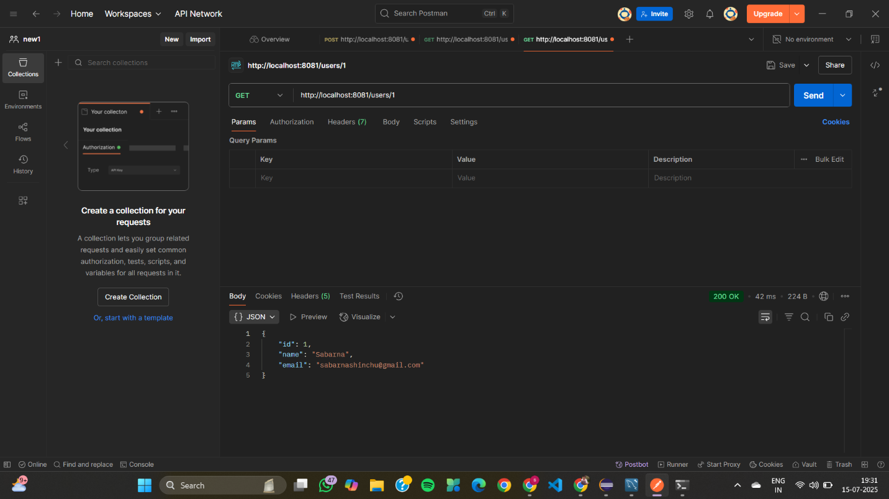
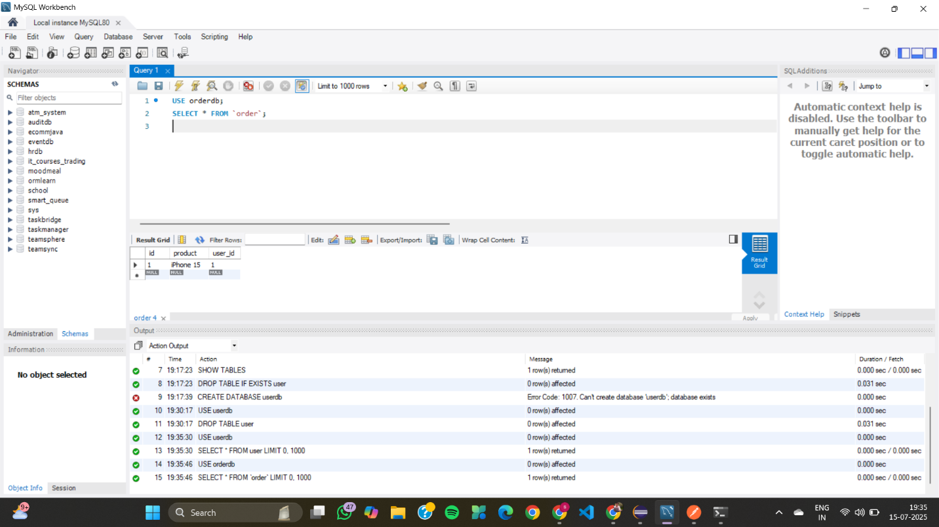
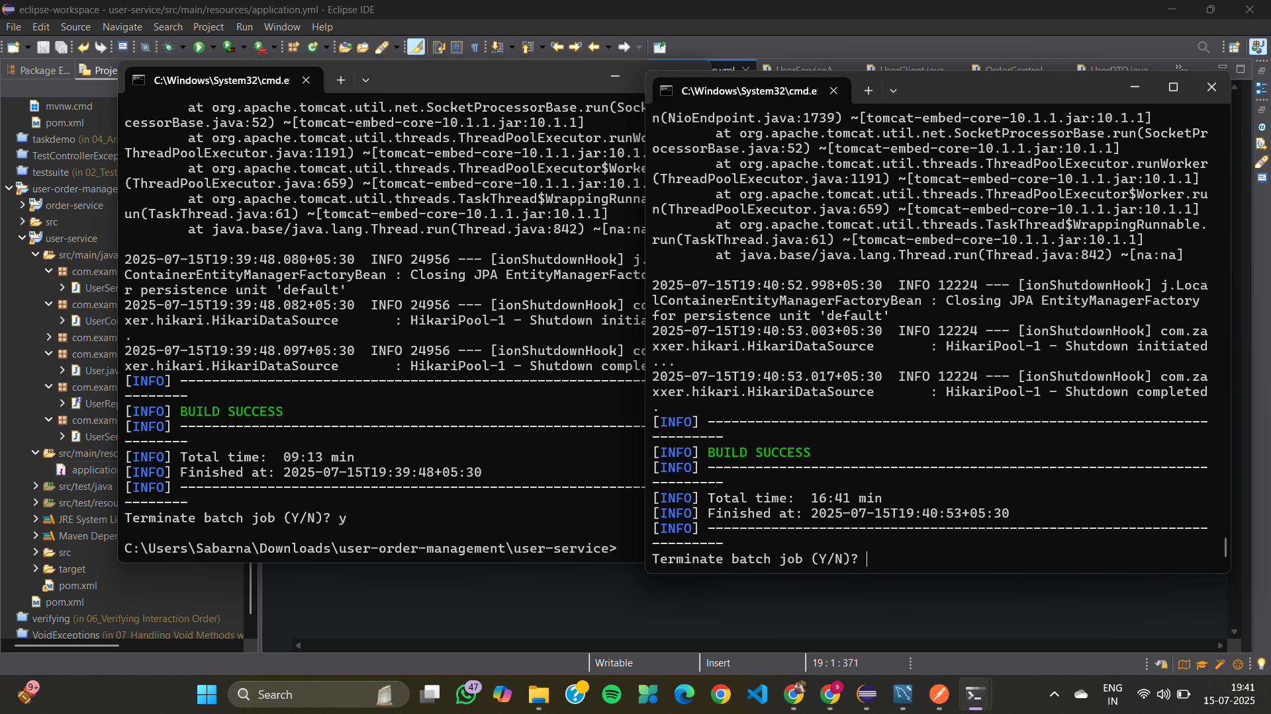
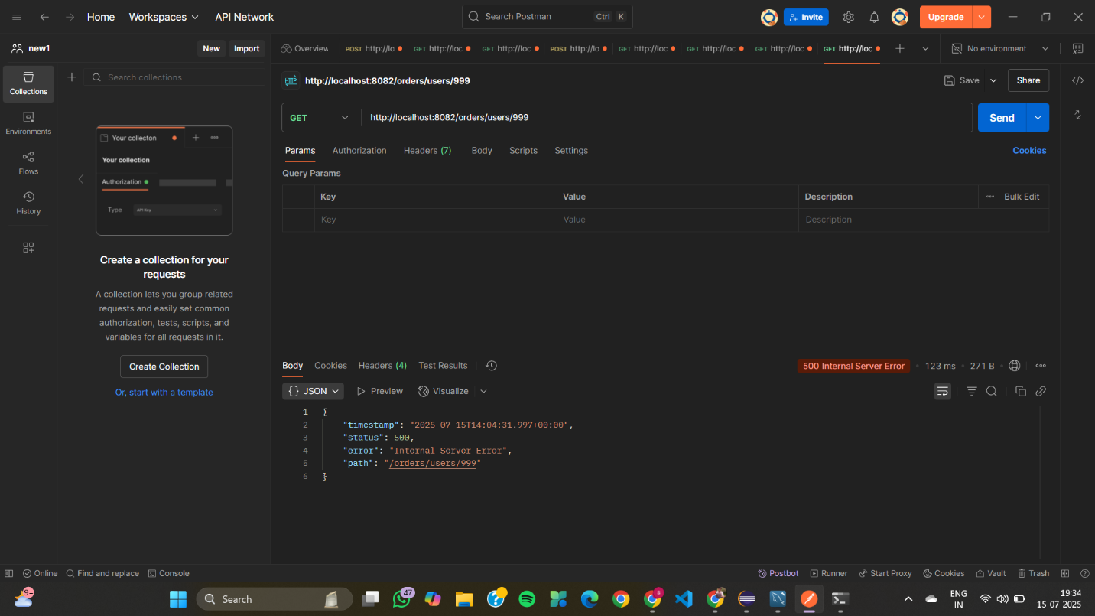
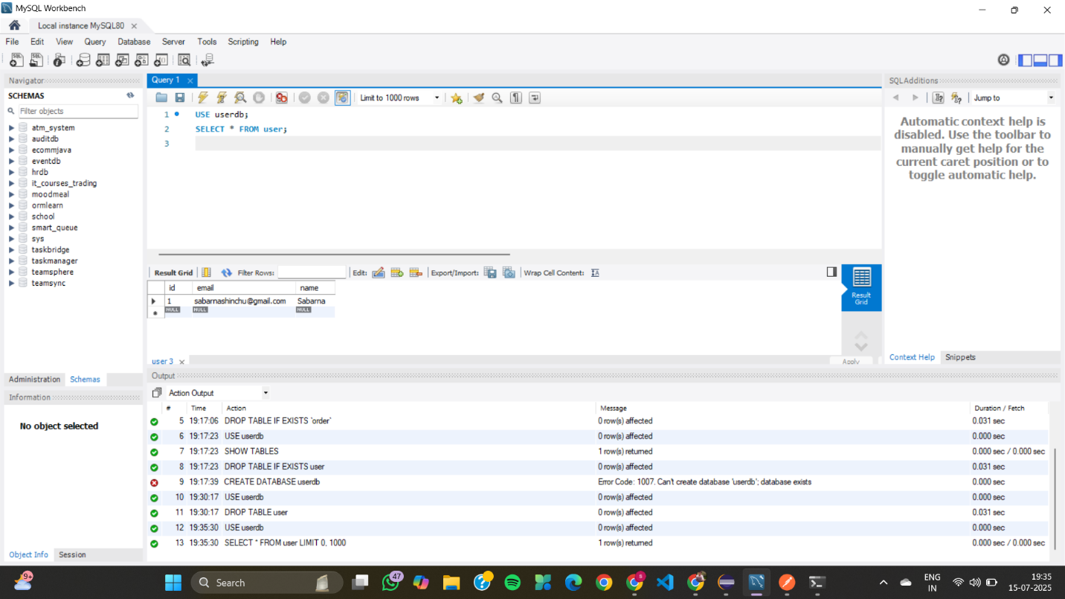

02_Inventory Management System with Service Discovery
config-server
ConfigServerApplication.java
package com.example.inventory.configserver;

import org.springframework.boot.SpringApplication;
import org.springframework.boot.autoconfigure.SpringBootApplication;
import org.springframework.cloud.config.server.EnableConfigServer;

@SpringBootApplication
@EnableConfigServer
public class ConfigServerApplication {
public static void main(String[] args) {
SpringApplication.run(ConfigServerApplication.class, args);
}
}
application.yml
server:
port: 8888

spring:
application:
name: config-server
cloud:
config:
server:
git:
uri: https://github.com/sabarnashinchu/inventory-config-repo.git
eureka-server
EurekaServerApplication.java
package com.example.inventory.eurekaserver;

import org.springframework.boot.SpringApplication;
import org.springframework.boot.autoconfigure.SpringBootApplication;
import org.springframework.cloud.netflix.eureka.server.EnableEurekaServer;

@SpringBootApplication
@EnableEurekaServer
public class EurekaServerApplication {
public static void main(String[] args) {
SpringApplication.run(EurekaServerApplication.class, args);
}
}
application.yml
server:
port: 8761

spring:
application:
name: eureka-server

eureka:
instance:
hostname: localhost
client:
register-with-eureka: false # Since it's a registry, not a client
fetch-registry: false # It doesn't fetch other services
inventory-service
InventoryController.java
package com.example.inventory.inventoryservice.controller;

import com.example.inventory.inventoryservice.feign.ProductClient;
import com.example.inventory.inventoryservice.model.Product;
import org.springframework.http.ResponseEntity;
import org.springframework.web.bind.annotation.*;

import java.util.Map;

@RestController
@RequestMapping("/inventory")
public class InventoryController {

private final ProductClient productClient;

public InventoryController(ProductClient productClient) {
this.productClient = productClient;
}

@GetMapping("/{id}")
public ResponseEntity<?> getInventory(@PathVariable("id") Long id) {
Product p;
try {
p = productClient.getProductById(id);
} catch (Exception ex) {
return ResponseEntity.status(500)
.body(Map.of("error", "Unable to retrieve product from Product Service", "details", ex.getMessage()));
}
if (p == null || p.getId() == null) {
return ResponseEntity.status(404).body(Map.of("error", "Product not found", "id", id));
}
return ResponseEntity.ok(Map.of(
"id", p.getId(),
"name", p.getName(),
"stock", p.getStock()
));
}
}
ProductClient.java
package com.example.inventory.inventoryservice.feign;

import com.example.inventory.inventoryservice.model.Product;
import org.springframework.cloud.openfeign.FeignClient;
import org.springframework.web.bind.annotation.GetMapping;
import org.springframework.web.bind.annotation.PathVariable;

@FeignClient(name = "product-service")
public interface ProductClient {
@GetMapping("/products/{id}")
Product getProductById(@PathVariable("id") Long id);
}
Product.java
package com.example.inventory.inventoryservice.model;

public class Product {
private Long id;
private String name;
private int stock;
public Long getId() { return id; } public void setId(Long id) { this.id = id; }
public String getName() { return name; } public void setName(String name) { this.name = name; }
public int getStock() { return stock; } public void setStock(int stock) { this.stock = stock; }
}
InventoryServiceApplication.java
package com.example.inventory.inventoryservice;

import org.springframework.boot.SpringApplication;
import org.springframework.boot.autoconfigure.SpringBootApplication;
import org.springframework.cloud.client.discovery.EnableDiscoveryClient;
import org.springframework.cloud.openfeign.EnableFeignClients;

@SpringBootApplication
@EnableDiscoveryClient
@EnableFeignClients
public class InventoryServiceApplication {
public static void main(String[] args) {
SpringApplication.run(InventoryServiceApplication.class, args);
}
}
application.yml
server:
port: 8082

spring:
application:
name: inventory-service

eureka:
client:
service-url:
defaultZone: http://localhost:8761/eureka/
instance:
prefer-ip-address: true
hostname: localhost
logging:
level:
com.example.inventory.inventoryservice: DEBUG
bootstrap.yml
spring:
application:
name: inventory-service
cloud:
config:
uri: http://localhost:8888
eureka:
client:
service-url:
defaultZone: http://localhost:8761/eureka/
instance:
prefer-ip-address: true
hostname: localhost
product-service
ProductController.java
package com.example.inventory.productservice.controller;
import com.example.inventory.productservice.model.Product;
import com.example.inventory.productservice.repository.ProductRepository;
import org.springframework.beans.factory.annotation.Autowired;
import org.springframework.web.bind.annotation.*;
import java.util.List;
@RestController
@RequestMapping("/products")
public class ProductController {
@Autowired
private ProductRepository productRepository;
@GetMapping("/{id}")
public Product getProduct(@PathVariable("id") Long id) {
return productRepository.findById(id)
.orElseThrow(() -> new RuntimeException("Product not found with id " + id));
}
@GetMapping
public List<Product> getAllProducts() {
return productRepository.findAll();
}
@PostMapping
public Product addProduct(@RequestBody Product product) {
return productRepository.save(product);
}
}
Product.java
package com.example.inventory.productservice.model;
import jakarta.persistence.*;
@Entity
public class Product {
@Id @GeneratedValue(strategy = GenerationType.IDENTITY)
private Long id;
private String name;
private int stock;
public Product() {}
public Product(String name, int stock) { this.name = name; this.stock = stock; }
public Long getId() { return id; } public void setId(Long id) { this.id = id; }
public String getName() { return name; } public void setName(String name) { this.name = name; }
public int getStock() { return stock; } public void setStock(int stock) { this.stock = stock; }
}
ProductRepository.java
package com.example.inventory.productservice.repository;
import com.example.inventory.productservice.model.Product;
import org.springframework.data.jpa.repository.JpaRepository;
public interface ProductRepository extends JpaRepository<Product, Long> {}
ProductServiceApplication.java
package com.example.inventory.productservice;
import org.springframework.boot.SpringApplication;
import org.springframework.boot.autoconfigure.SpringBootApplication;
import org.springframework.cloud.client.discovery.EnableDiscoveryClient;
@SpringBootApplication
@EnableDiscoveryClient
public class ProductServiceApplication {
public static void main(String[] args) {
SpringApplication.run(ProductServiceApplication.class, args);
}
}
application.yml
server:
port: 8081
spring:
application:
name: product-service
datasource:
url: jdbc:h2:mem:productdb
driverClassName: org.h2.Driver
username: sa
password:
jpa:
hibernate:
ddl-auto: update
show-sql: true
h2:
console:
enabled: true
path: /h2-console
eureka:
client:
service-url:
defaultZone: http://localhost:8761/eureka/
instance:
prefer-ip-address: true
hostname: localhost

bootstrap.yml
spring:
application:
name: product-service # or inventory-service for inventory
cloud:
config:
uri: http://localhost:8888
eureka:
client:
service-url:
defaultZone: http://localhost:8761/eureka/
instance:
prefer-ip-address: true
hostname: localhost
OUTPUT
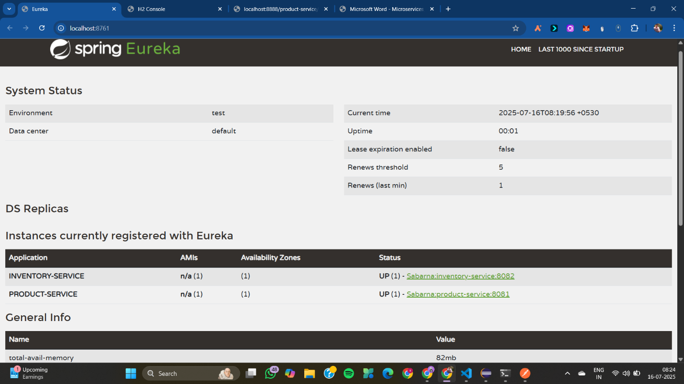

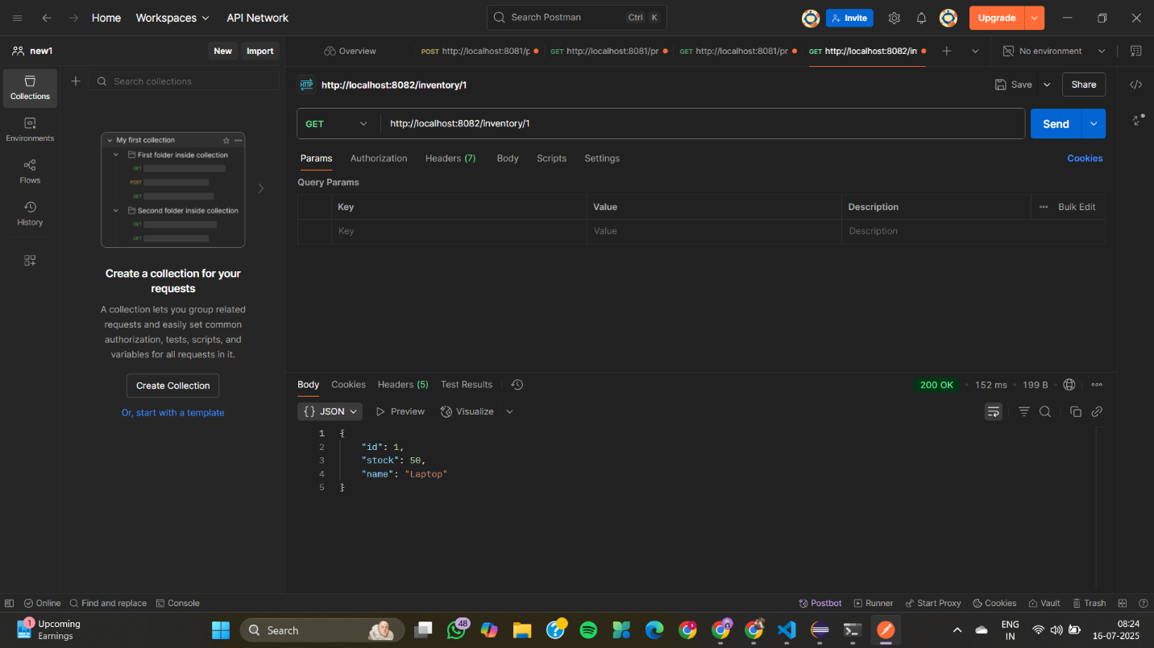
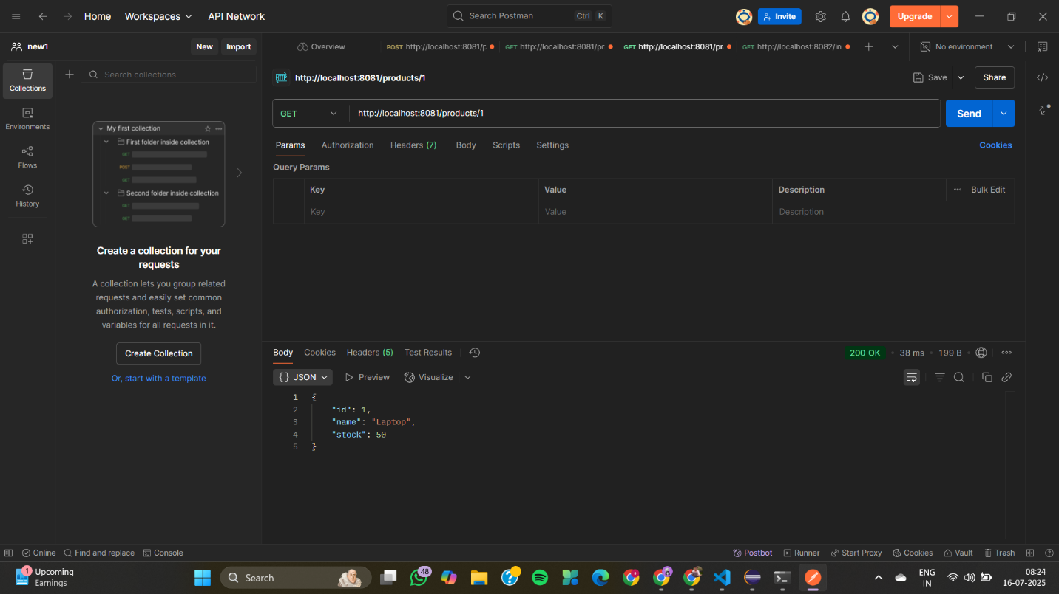
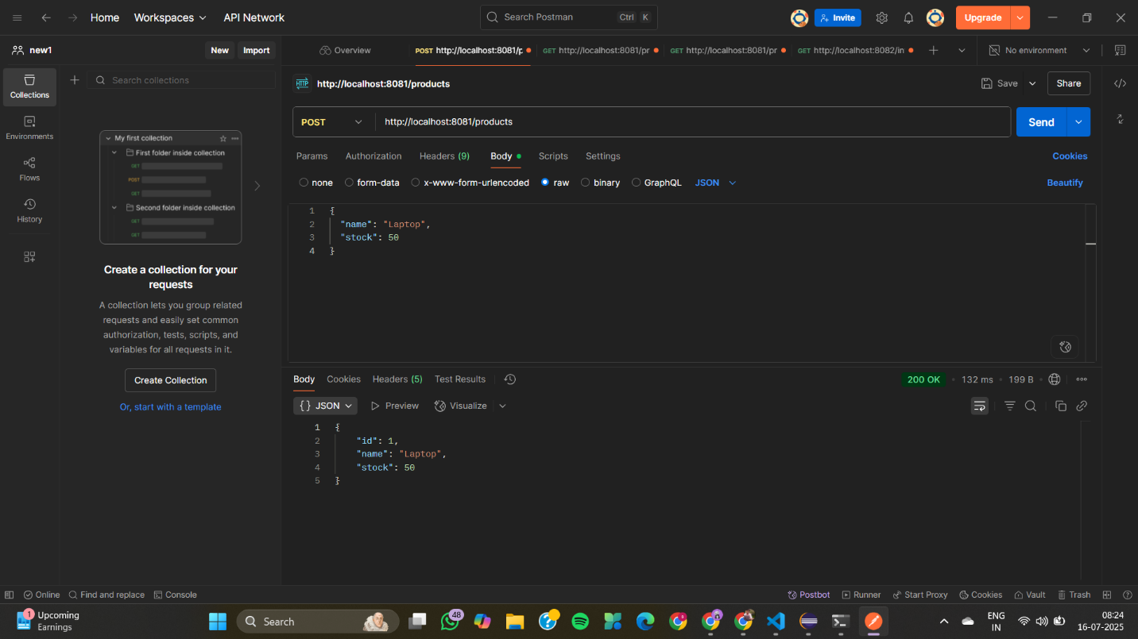
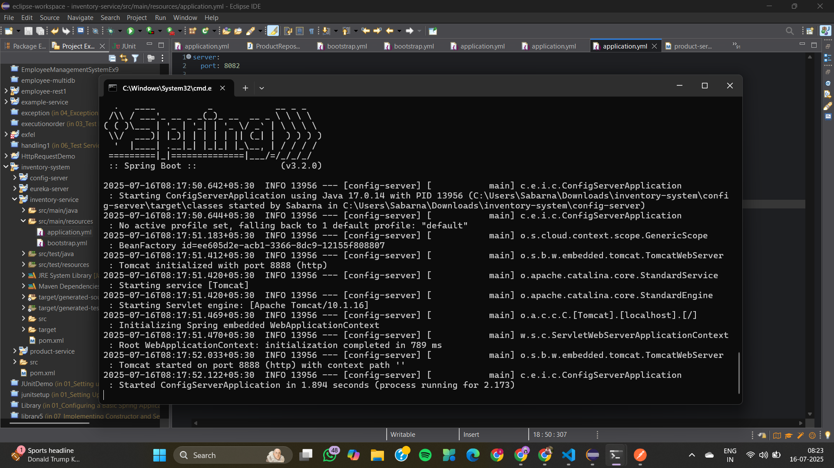
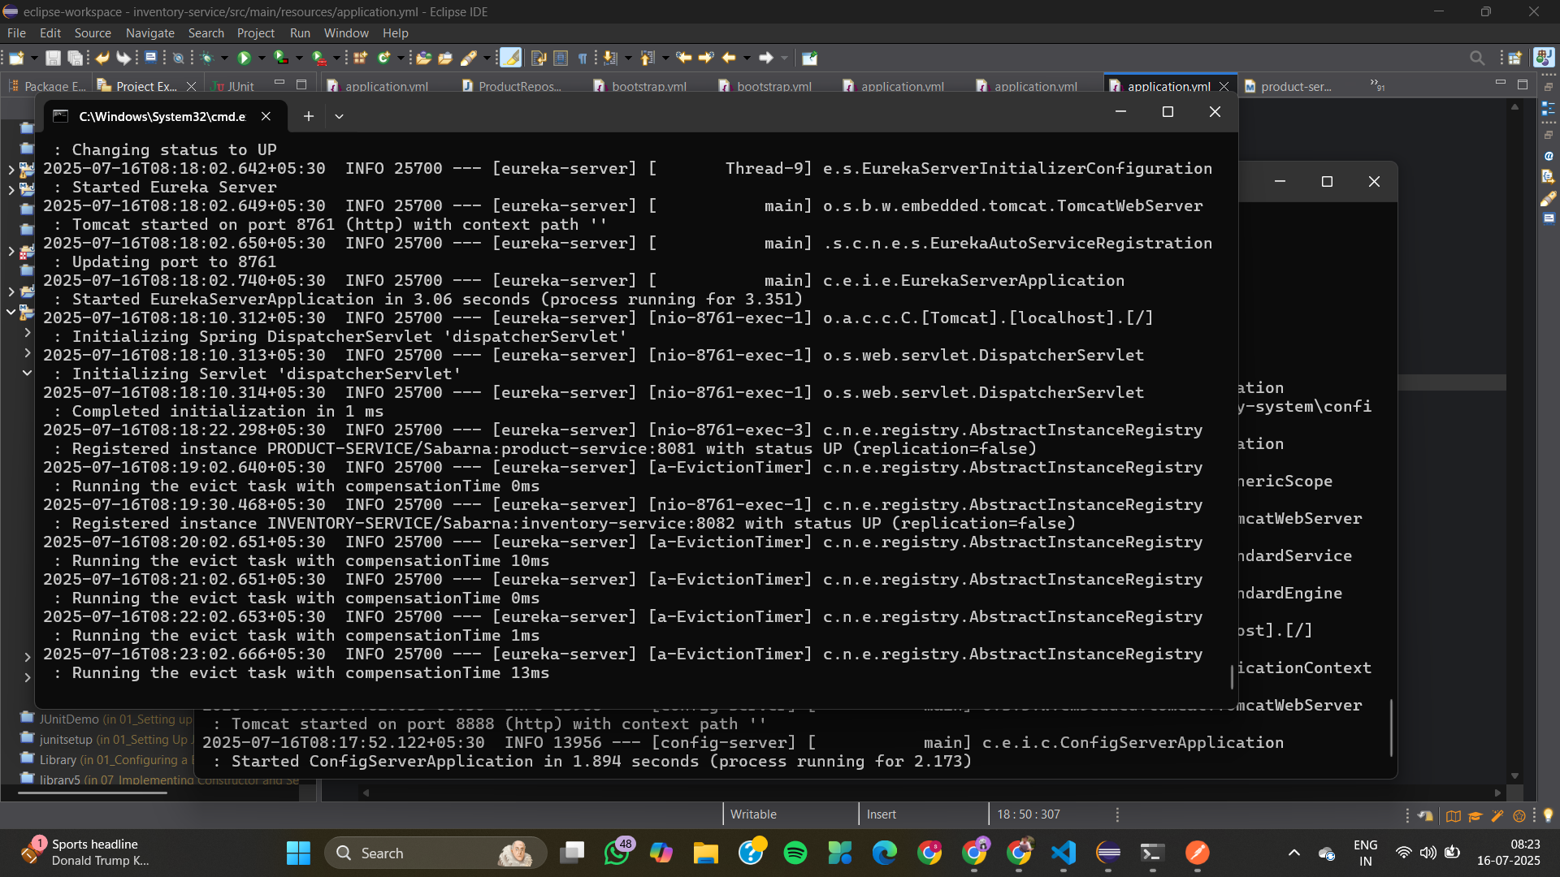
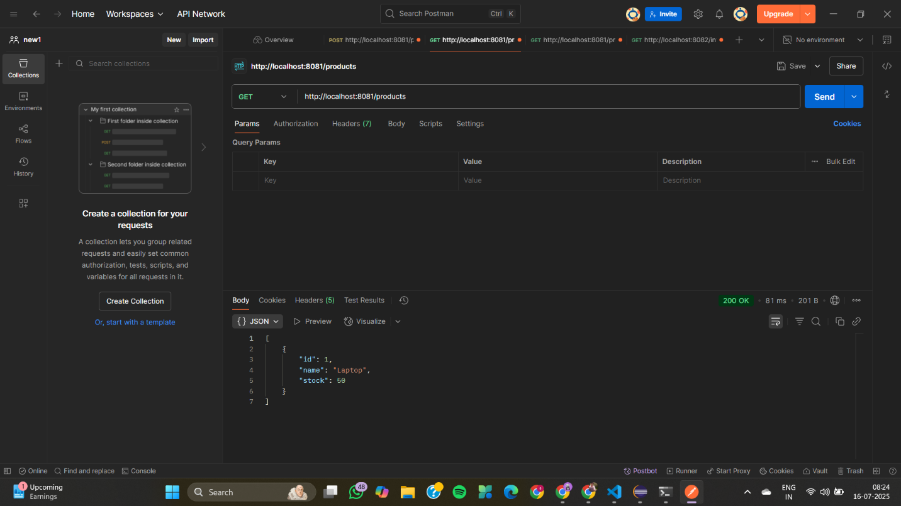
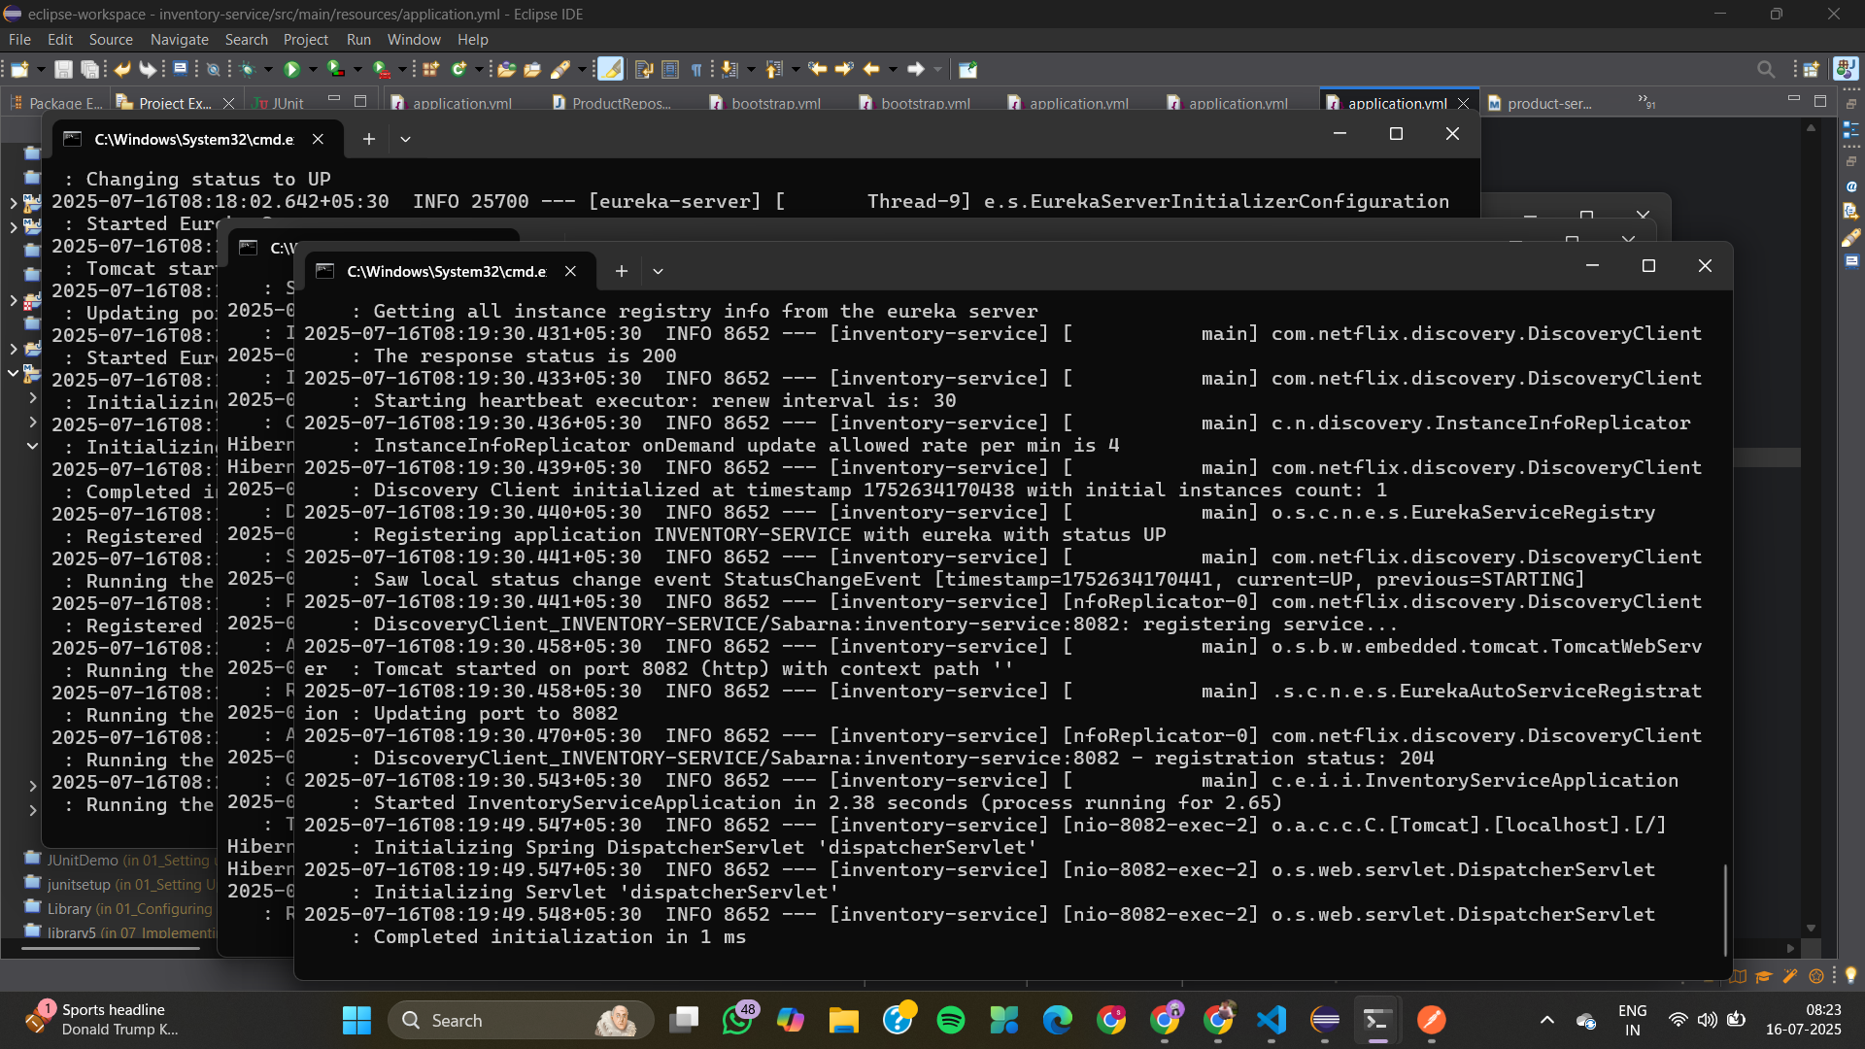
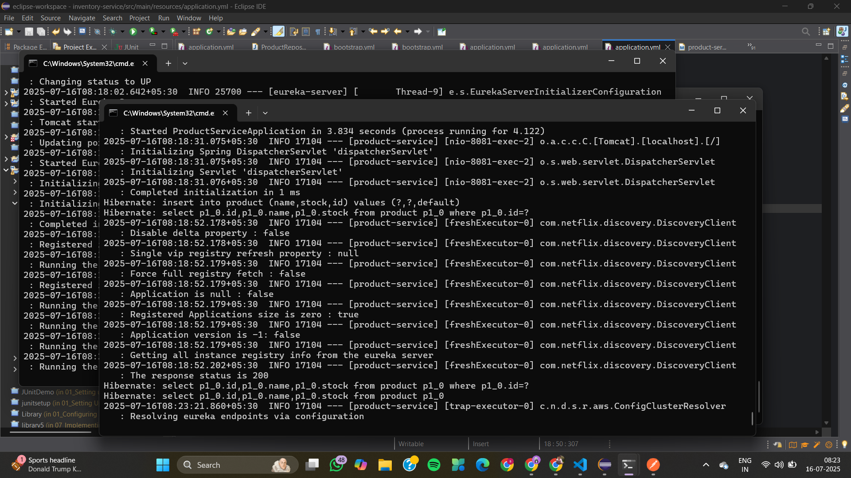
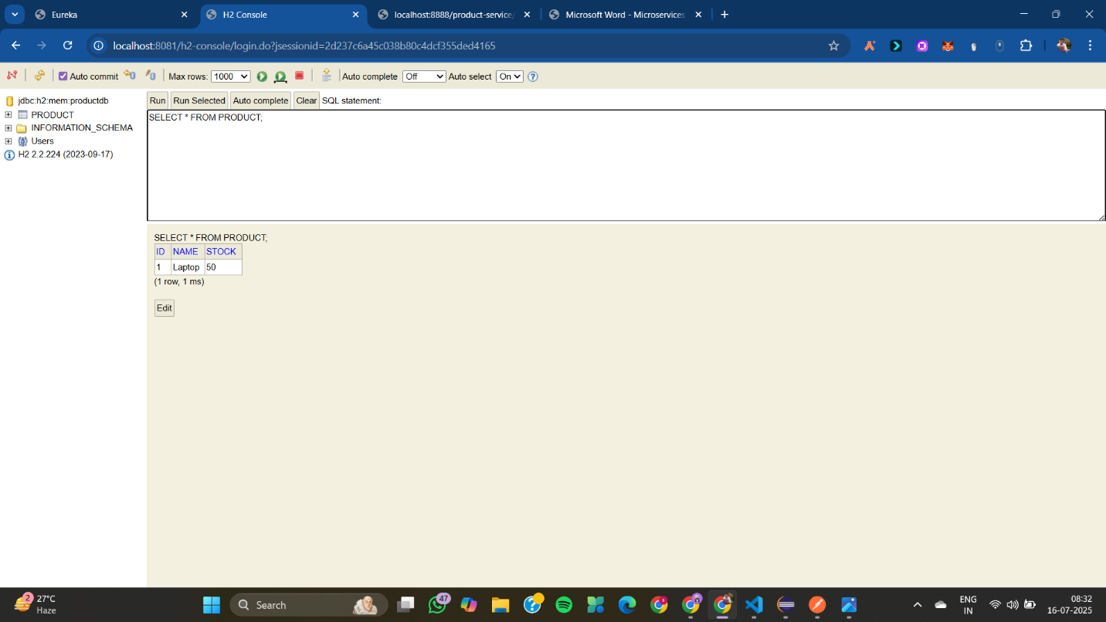
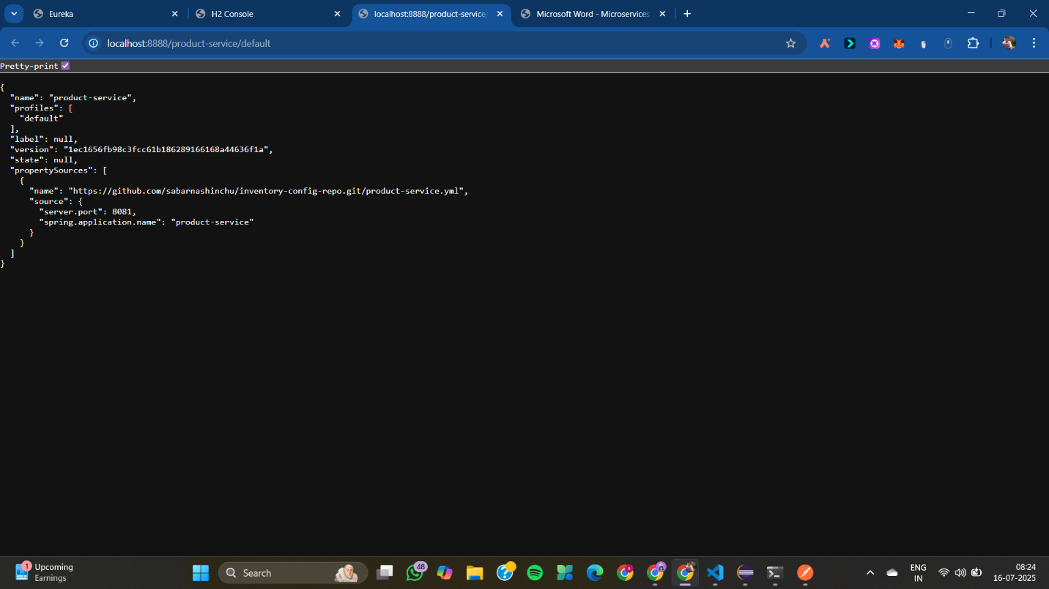

03_Implement an API Gateway
api-gateway
RateLimiterConfig.java
package com.example.apigateway.config;

import org.springframework.cloud.gateway.filter.ratelimit.KeyResolver;
import org.springframework.context.annotation.Bean;
import org.springframework.context.annotation.Configuration;
import reactor.core.publisher.Mono;

@Configuration
public class RateLimiterConfig {

// Rate limiting key: based on IP
@Bean
public KeyResolver ipKeyResolver() {
return exchange -> Mono.just(exchange.getRequest().getRemoteAddress().getAddress().getHostAddress());
}
}
ResponseTimeFilter.java
package com.example.apigateway.filter;

import org.springframework.cloud.gateway.filter.GlobalFilter;
import org.springframework.core.Ordered;
import org.springframework.http.server.reactive.ServerHttpResponse;
import org.springframework.stereotype.Component;
import org.springframework.web.server.ServerWebExchange;
import reactor.core.publisher.Mono;

import java.time.LocalDateTime;

@Component
public class ResponseTimeFilter implements GlobalFilter, Ordered {

@Override
public Mono<Void> filter(ServerWebExchange exchange, org.springframework.cloud.gateway.filter.GatewayFilterChain chain) {
// Add header BEFORE the response is committed
exchange.getResponse().getHeaders().add("X-Timestamp", LocalDateTime.now().toString());
return chain.filter(exchange);
}

@Override
public int getOrder() {
return -1; // high priority
}
}
ApiGatewayApplication.java
package com.example.apigateway;

import org.springframework.boot.SpringApplication;
import org.springframework.boot.autoconfigure.SpringBootApplication;

@SpringBootApplication
public class ApiGatewayApplication {
public static void main(String[] args) {
SpringApplication.run(ApiGatewayApplication.class, args);
}
}
application.yml
server:
port: 8080

spring:
application:
name: api-gateway

redis:
host: localhost
port: 6379

cloud:
gateway:
routes:
- id: customer-service
uri: http://localhost:8081
predicates:
- Path=/customer/**
filters:
- RewritePath=/customer/(?<segment>.*), /${segment}
- name: RequestRateLimiter
args:
redis-rate-limiter.replenishRate: 5
redis-rate-limiter.burstCapacity: 10

- id: billing-service
uri: http://localhost:8082
predicates:
- Path=/billing/**
filters:
- RewritePath=/billing/(?<segment>.*), /${segment}

management:
endpoints:
web:
exposure:
include: "*"
billing-service
BillingController.java
package com.example.billing;

import org.springframework.web.bind.annotation.GetMapping;
import org.springframework.web.bind.annotation.RestController;

@RestController
public class BillingController {

@GetMapping("/hello")
public String helloBilling() {
return "Hello from Billing Service!";
}

@GetMapping("/test")
public String testBilling() {
return "Test endpoint from Billing Service!";
}
}
BillingServiceApplication.java
package com.example.billing;

import org.springframework.boot.SpringApplication;
import org.springframework.boot.autoconfigure.SpringBootApplication;

@SpringBootApplication
public class BillingServiceApplication {
public static void main(String[] args) {
SpringApplication.run(BillingServiceApplication.class, args);
}
}
application.yml
server:
port: 8082

spring:
application:
name: billing-service
customer-service
CustomerController.java
package com.example.customer;

import org.springframework.web.bind.annotation.GetMapping;
import org.springframework.web.bind.annotation.RestController;

@RestController
public class CustomerController {

@GetMapping("/hello")
public String helloCustomer() {
return "Hello from Customer Service!";
}

@GetMapping("/test")
public String testCustomer() {
return "Test endpoint from Customer Service!";
}
}
CustomerServiceApplication.java
package com.example.customer;

import org.springframework.boot.SpringApplication;
import org.springframework.boot.autoconfigure.SpringBootApplication;

@SpringBootApplication
public class CustomerServiceApplication {
public static void main(String[] args) {
SpringApplication.run(CustomerServiceApplication.class, args);
}
}
application.yml
server:
port: 8081

spring:
application:
name: customer-service
OUTPUT
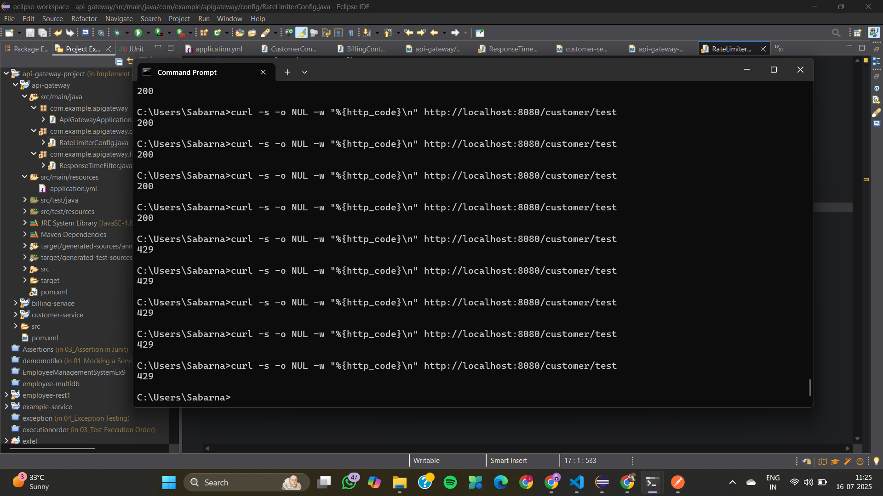
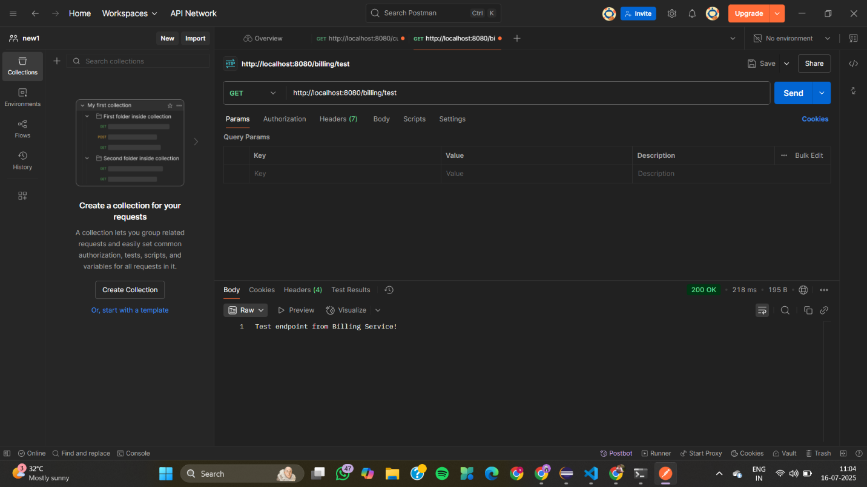
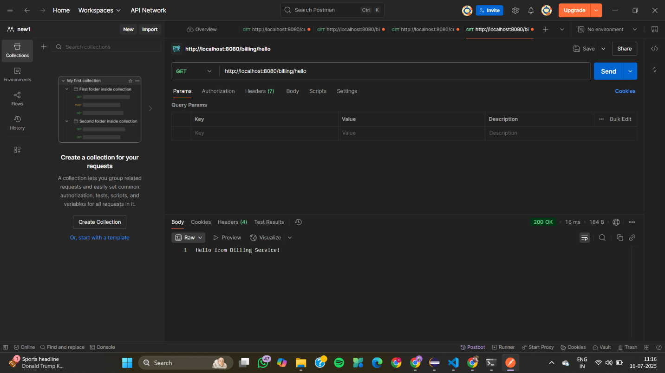
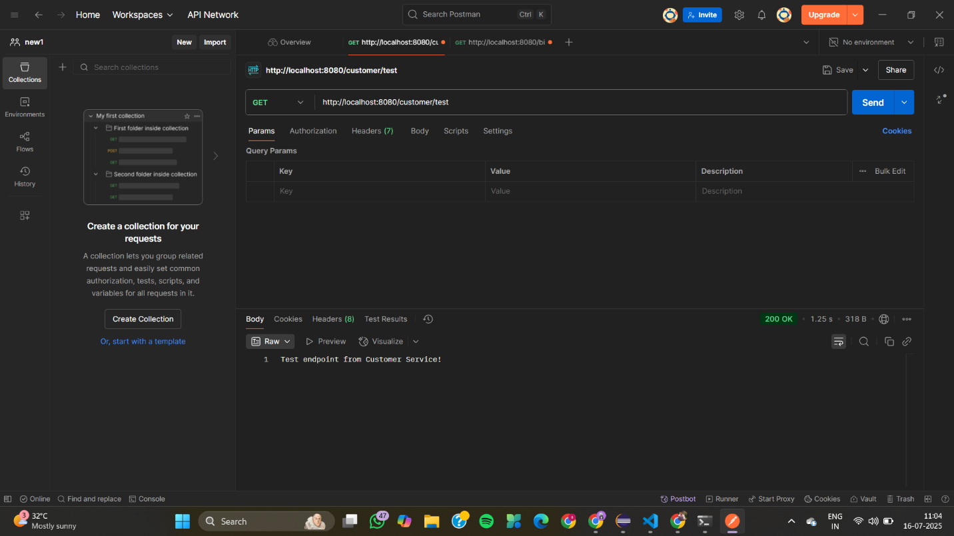
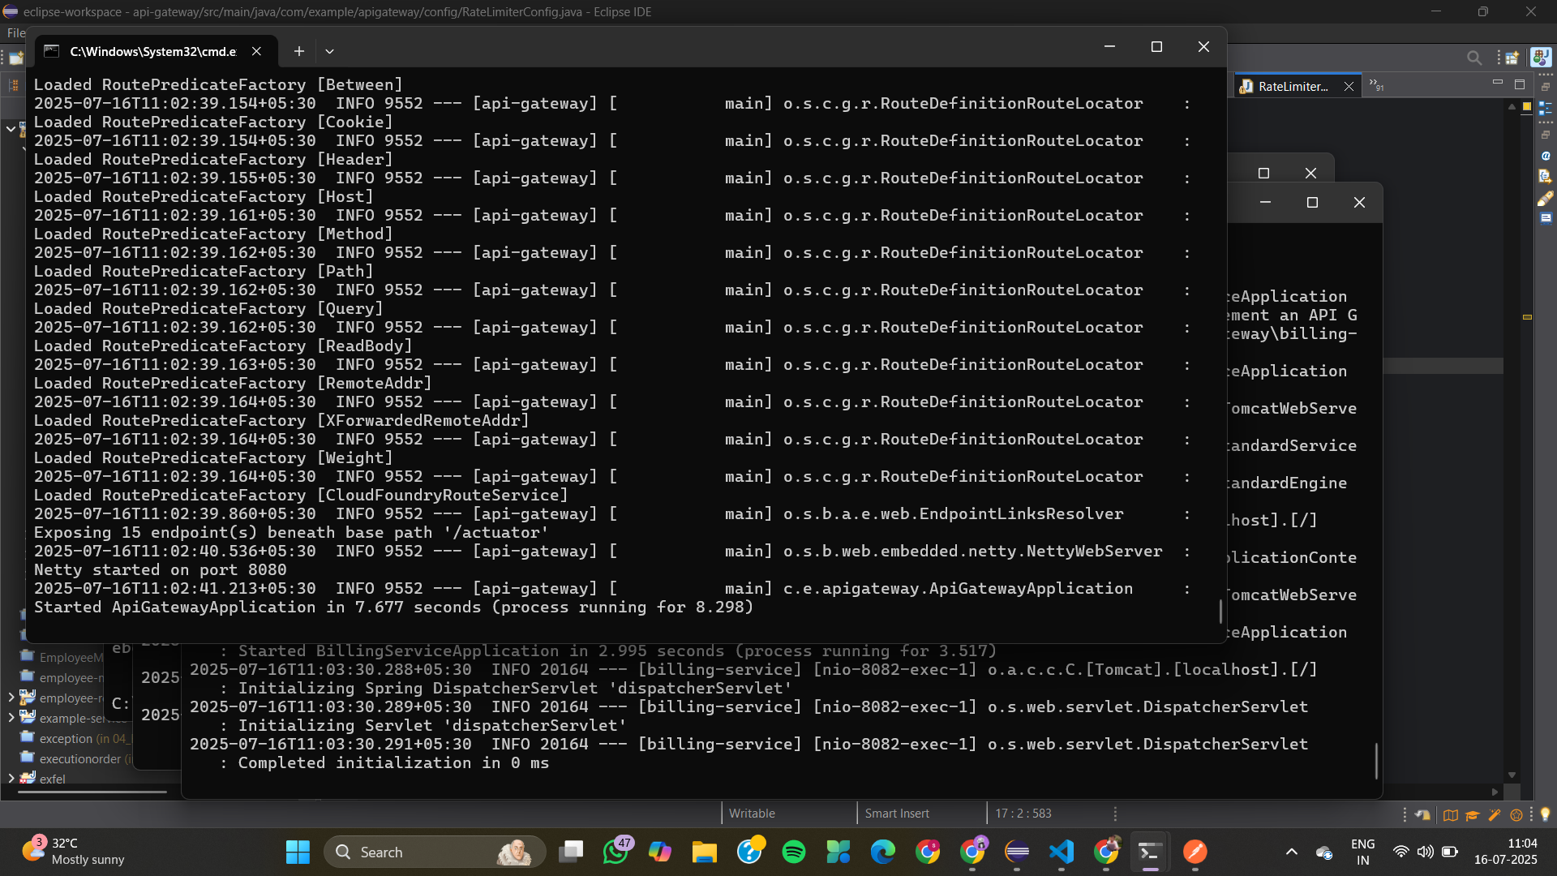
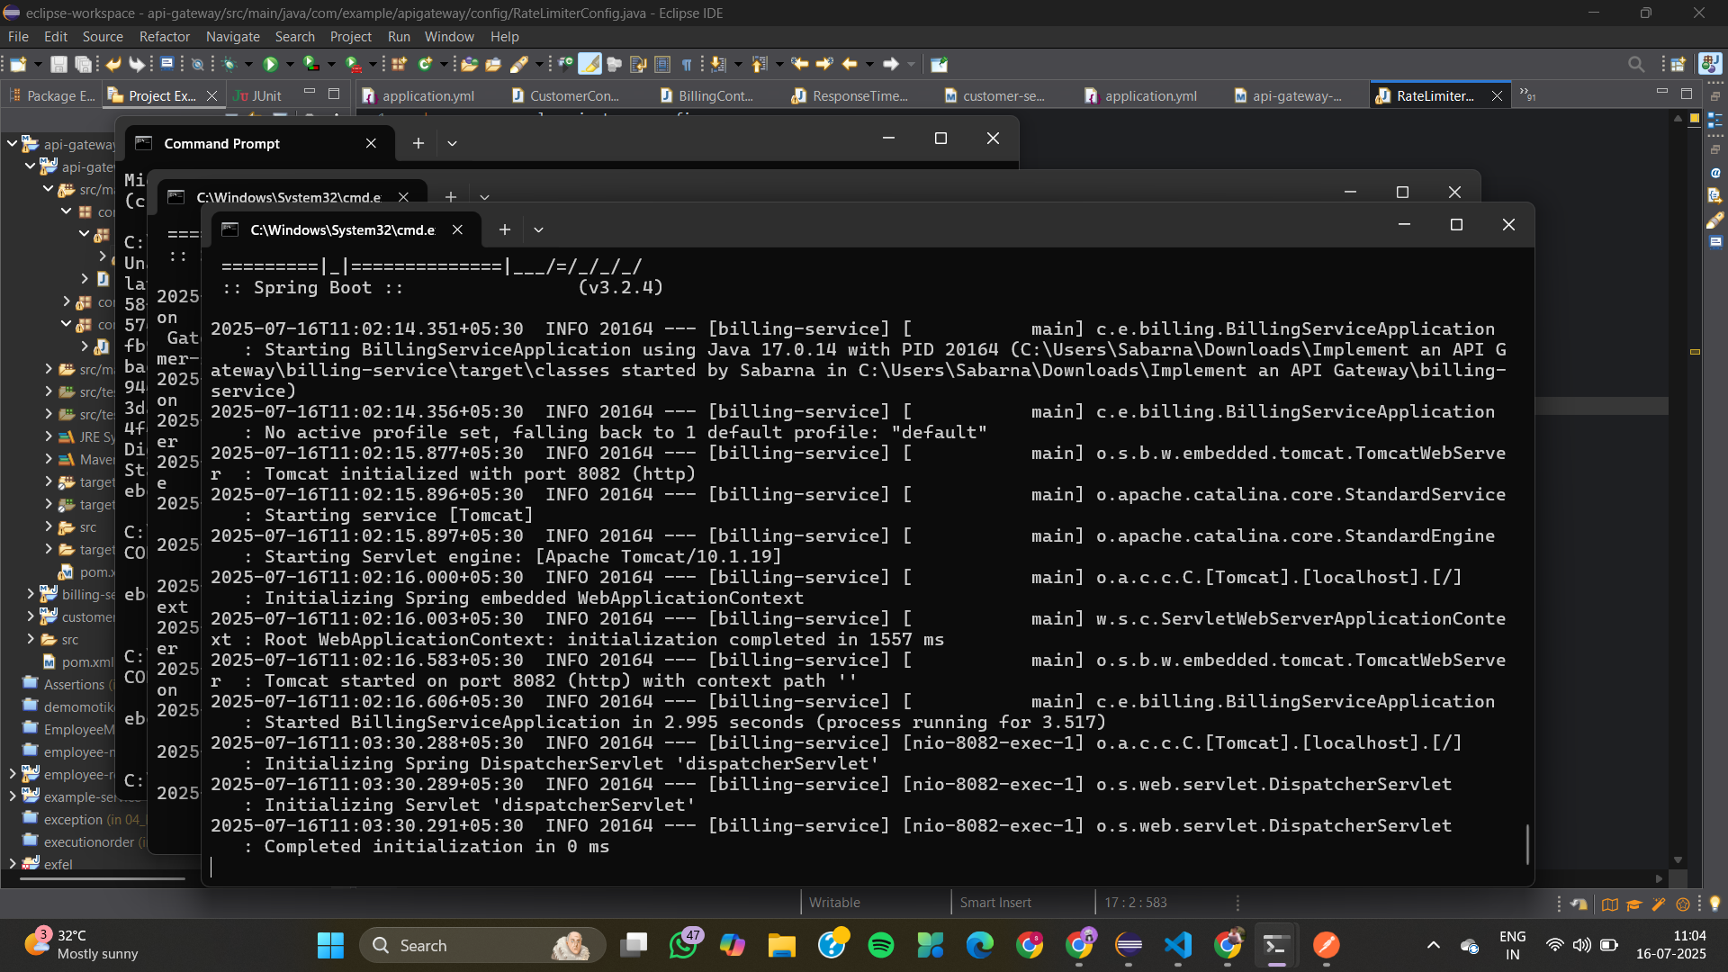
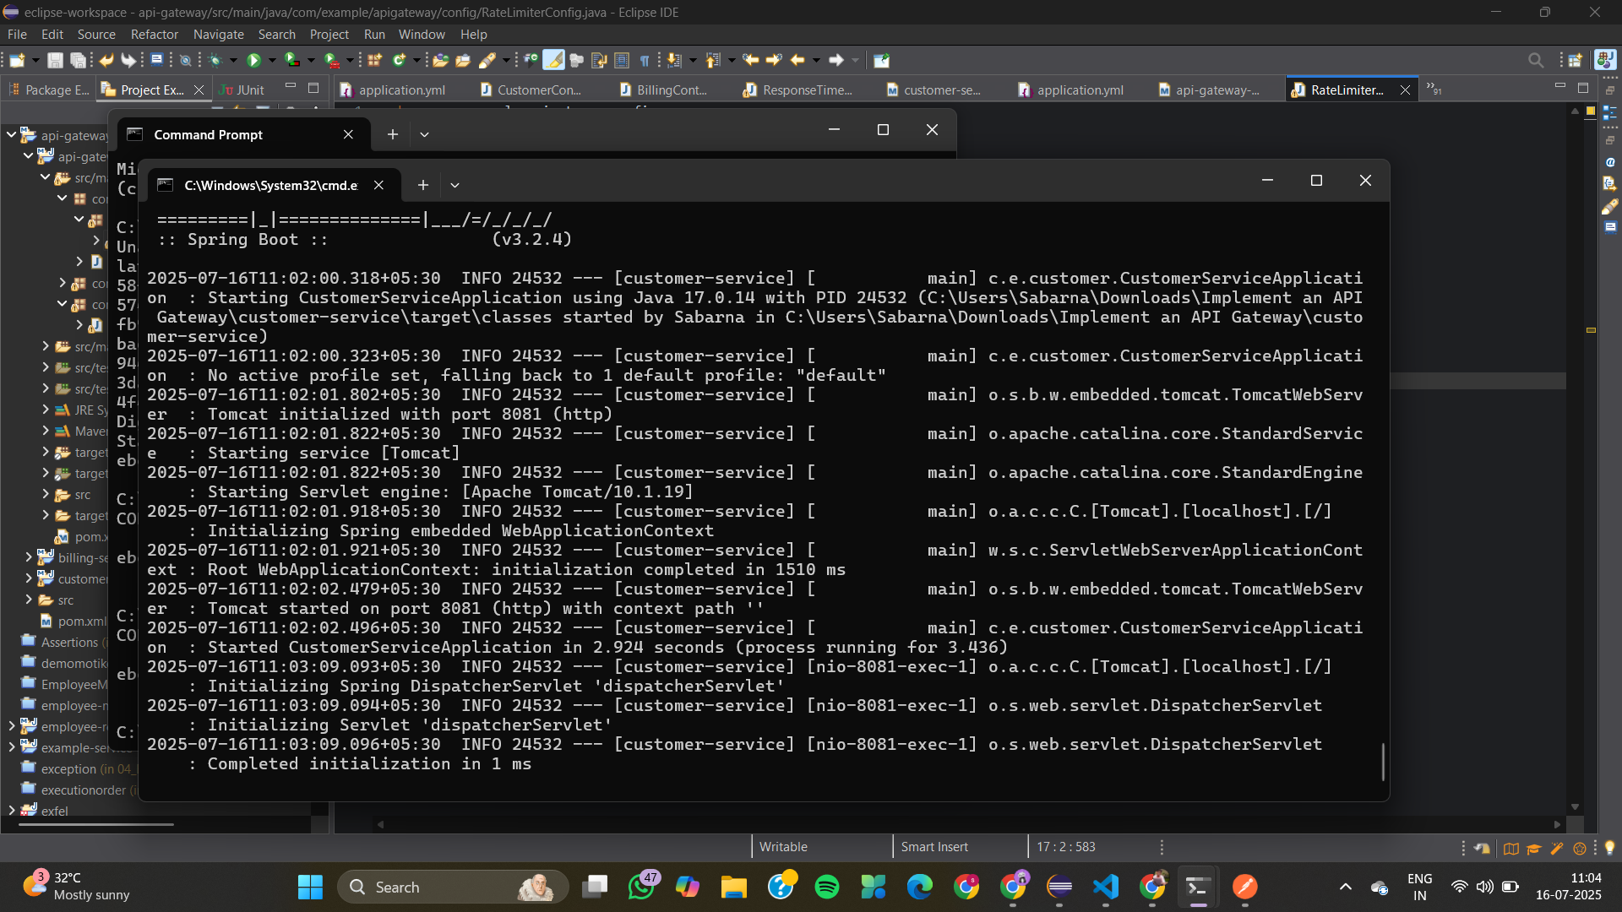
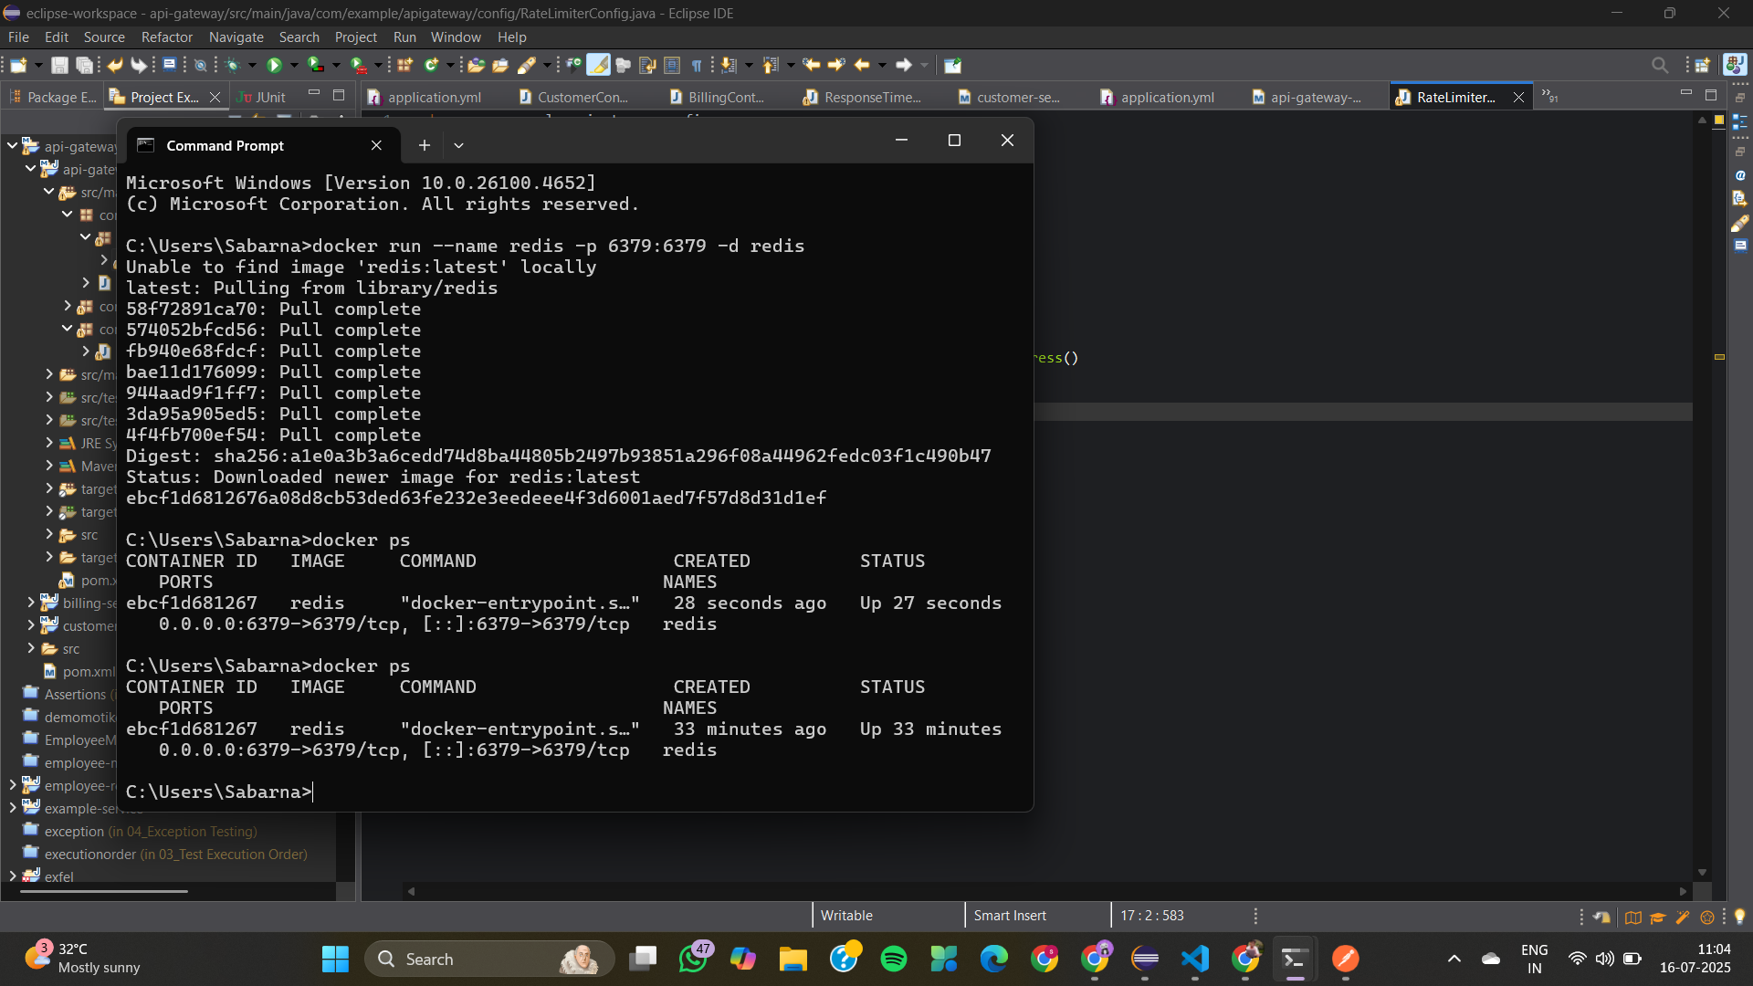
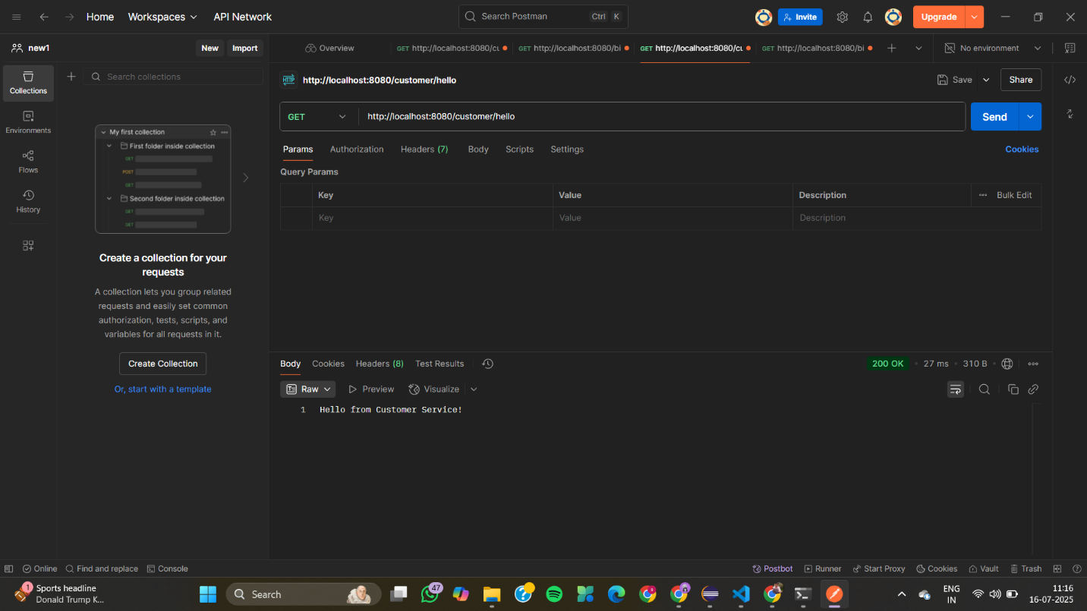

04_Resilient Microservices with Circuit Breaker
PaymentController.java
package com.example.payment.controller;

import com.example.payment.service.PaymentService;
import org.springframework.beans.factory.annotation.Autowired;
import org.springframework.http.ResponseEntity;
import org.springframework.web.bind.annotation.GetMapping;
import org.springframework.web.bind.annotation.PathVariable;
import org.springframework.web.bind.annotation.RequestMapping;
import org.springframework.web.bind.annotation.RestController;

@RestController
@RequestMapping("/payment")
public class PaymentController {

@Autowired
private PaymentService paymentService;

@GetMapping("/process/{transactionId}")
public ResponseEntity<String> processPayment(@PathVariable String transactionId) {
String result = paymentService.processPayment(transactionId);
return ResponseEntity.ok(result);
}
}
PaymentService.java
package com.example.payment.service;

import io.github.resilience4j.circuitbreaker.annotation.CircuitBreaker;
import org.slf4j.Logger;
import org.slf4j.LoggerFactory;
import org.springframework.beans.factory.annotation.Autowired;
import org.springframework.stereotype.Service;

@Service
public class PaymentService {

private static final Logger log = LoggerFactory.getLogger(PaymentService.class);

@Autowired
private ThirdPartyApiClient thirdPartyApiClient;

private static final String PAYMENT_SERVICE = "thirdPartyPaymentService"; // Matches name in application.properties

@CircuitBreaker(name = PAYMENT_SERVICE, fallbackMethod = "processPaymentFallback")
public String processPayment(String transactionId) {
log.info("Attempting to process payment for transaction: {}", transactionId);
return thirdPartyApiClient.callExternalPaymentGateway(transactionId);
}

// Fallback method must have the same signature as the original method, plus a Throwable parameter
public String processPaymentFallback(String transactionId, Throwable t) {
log.warn("Fallback triggered for transaction: {}. Reason: {}", transactionId, t.getMessage());
// Log the fallback event specifically for monitoring
logFallbackEvent(transactionId, t.getClass().getSimpleName(), t.getMessage());
return "Payment processing failed. Falling back to alternative method. Please try again later. (Transaction ID: " + transactionId + ")";
}

private void logFallbackEvent(String transactionId, String exceptionType, String errorMessage) {
// Here you would typically send this event to a monitoring system (e.g., Prometheus, Grafana, ELK stack)
// For demonstration, we'll just log it.
log.error("!!!!! FALLBACK EVENT DETECTED !!!!! TransactionId: {}, ExceptionType: {}, ErrorMessage: {}",
transactionId, exceptionType, errorMessage);
}
}
PaymentApplication.java
package com.example.payment;

import org.springframework.boot.SpringApplication;
import org.springframework.boot.autoconfigure.SpringBootApplication;

@SpringBootApplication
public class PaymentApplication {

public static void main(String[] args) {
SpringApplication.run(PaymentApplication.class, args);
}
}
application.properties
# Server Port
server.port=8080

# Resilience4j Circuit Breaker Configuration
resilience4j.circuitbreaker.instances.thirdPartyPaymentService.registerHealthIndicator=true
resilience4j.circuitbreaker.instances.thirdPartyPaymentService.failureRateThreshold=50
resilience4j.circuitbreaker.instances.thirdPartyPaymentService.waitDurationInOpenState=5s
resilience4j.circuitbreaker.instances.thirdPartyPaymentService.slidingWindowType=COUNT_BASED
resilience4j.circuitbreaker.instances.thirdPartyPaymentService.slidingWindowSize=10
resilience4j.circuitbreaker.instances.thirdPartyPaymentService.permittedNumberOfCallsInHalfOpenState=3

# Logging configuration
logging.level.com.example.payment=DEBUG
logging.level.io.github.resilience4j=DEBUG

OUTPUT
